Penetration Testing Executive Summary (PTES)

Executive Summary
A PTES-based penetration test was conducted against the target host 192.168.77.135. The assessment successfully identified critical vulnerabilities, leading to full remote root compromise. The outdated software stack and lack of basic security controls make the system extremely vulnerable to attack.

Findings
- ARP scan revealed the target 192.168.77.135 on the local network (VMware environment).
- Nmap scan showed open ports: 22 (SSH v1.99 – weak protocol), 80 (Apache 1.3.20), 139 (Samba 2.2.1a), 443 (SSLv2 enabled – insecure).
- Samba version 2.2.1a is known to be vulnerable to a remote root exploit.
- Enum4linux-ng confirmed OS: Linux/Unix running Samba 2.2.1a.
- Exploit compilation and execution (gcc 10.c -o exp; ./exp -b 0 192.168.77.135) successfully returned a root shell (uid=0(root)).

Recommendations
- Immediately patch or upgrade Samba to a version not vulnerable to remote root exploits.
- Disable SSLv2 and upgrade OpenSSL/Apache to modern versions.
- Replace SSHv1 with SSHv2 only.
- Apply OS updates (current kernel: 2.4.7-10 from 2001).
- Implement network segmentation to limit exposure of legacy systems.

Steps to Replicate
1. Perform network discovery using ARP scan to identify active hosts.
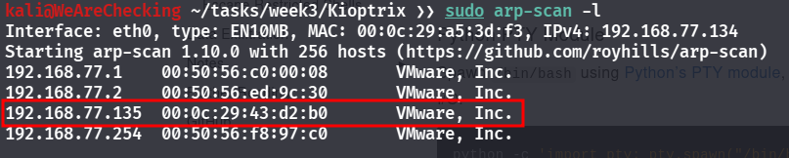
2. Conduct port scanning using Nmap to identify open services and versions.
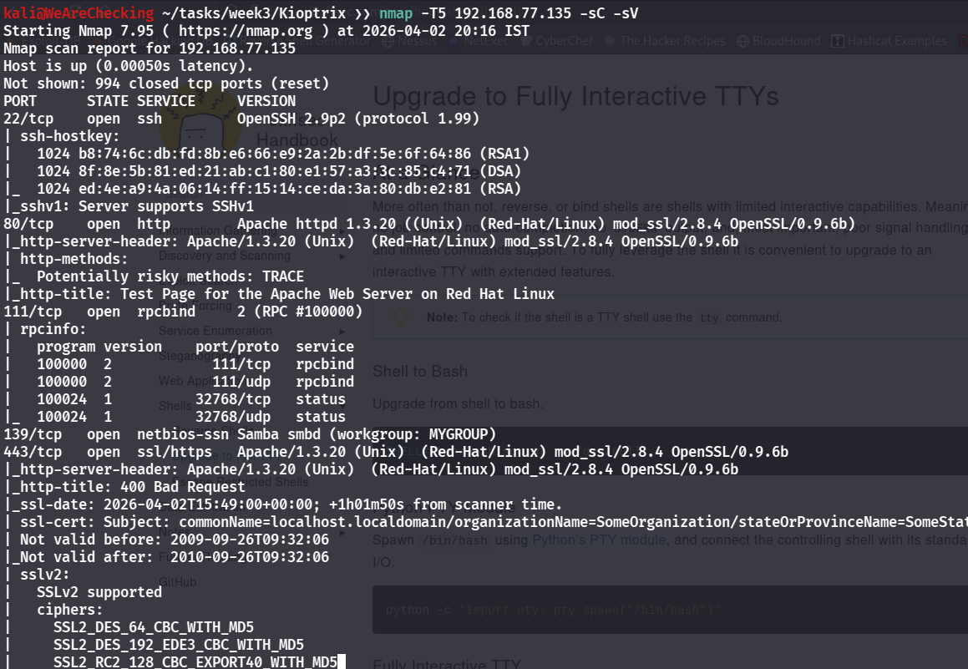
3. Enumerate SMB services using enum4linux-ng.

4. Identify vulnerable Samba version (2.2.1a).
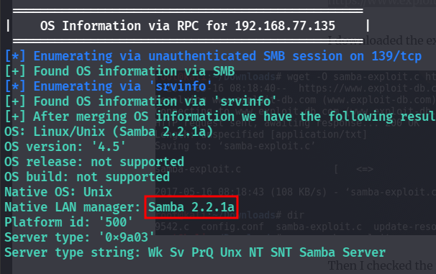
5. Search and find exploit on web
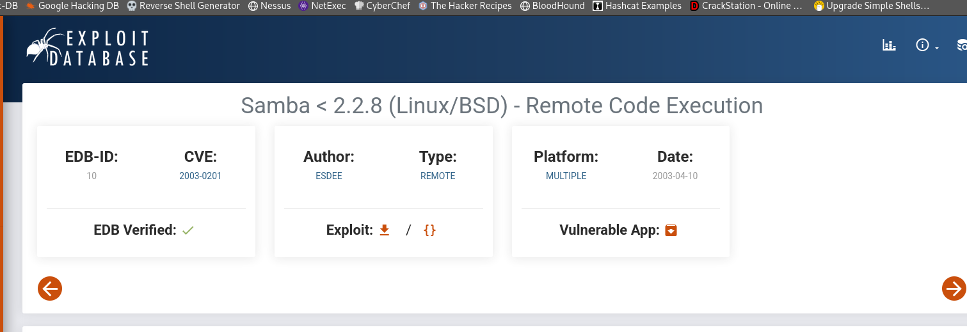
6. Compile exploit code using gcc (gcc 10.c -o exp).
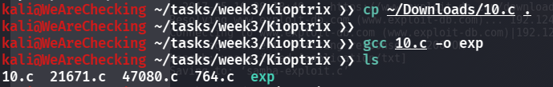
7. Execute exploit against target
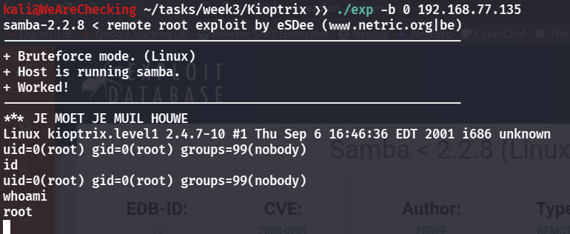
8. Verify root shell access (uid=0).
